**Tilt Brush** by Google

Tilt Brush lets you paint in 3D space with virtual reality. Paint life-size three-dimensional brush strokes, stars, light, and even fire. Experience painting as you have never before.

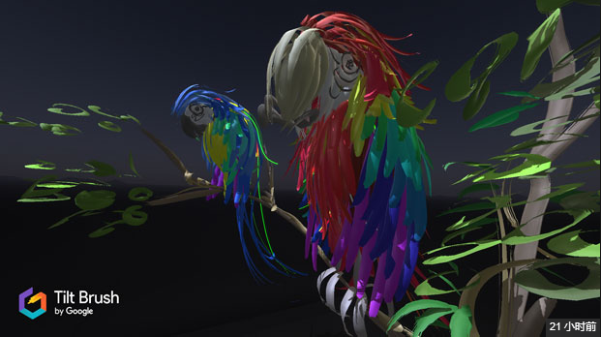

**Kodon** by Tenk Labs - Release Date : Sep 21, 2016

Kodon is a 3D sculpting program for roomscale VR. It allows you to freely shape objects in 1:1 roomscale. You can map up physical objects in your room to be viewed in VR, allowing you to use physical desks and tools for stability and precision in the 3D sculpting process.

Kodon opens up for a degree of precision and control that invites you to both casually play around for hours in VR. It also allows artists without 3D experience to create quality 3D models without any instructions.

Experienced 3D modelers are offered professional control over the result by allowing importing of existing meshes from all major 3D applications using the .obj format, and exporting back.

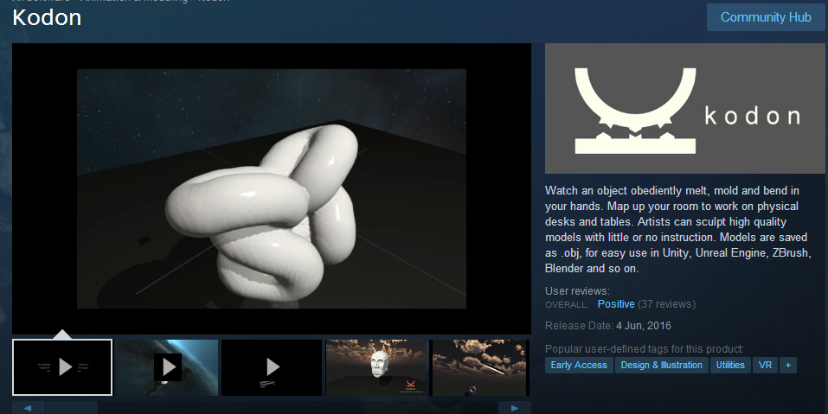

Kodon Early Access Software

**Modbox**

A VR multiplayer sandbox game create your own game experiences to play and share with others.

Oculus **Medium**

Oculus Medium brings art and play together in ways never before possible. Built specifically for virtual reality, Medium lets you sculpt, model, paint, and create solid-feeling objects in a VR environment.

With Medium, you can quickly and seamlessly produce incredible works of art, no matter if you're a total beginner, aspiring creative, or professional artist. Oculus Medium uses Touch controllers to enable authentic hand gestures and movement for a natural, tactile experience.

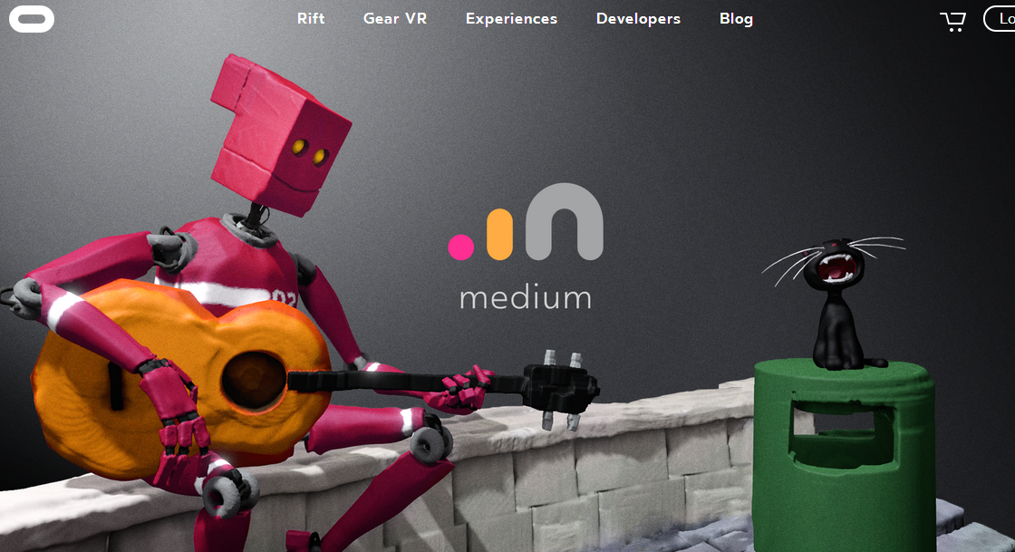

Oculus **Quill**

Quill works much like Tilt Brush, the VR painting app Google acquired. Using Oculus’ Touch controllers and motion cameras, Quill users can select different brushes and colors, swing their hands through the air, and each flourish appears instantly within the 3D canvas.

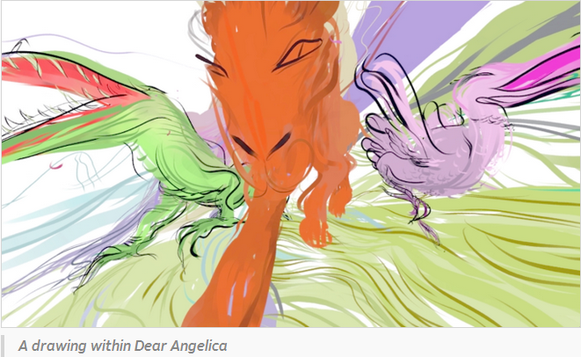

**Virtually Real**

A collaborative pop-up project between the virtual reality platform HTC Vive and our contemporary art school, the [Royal Academy Schools](https://www.royalacademy.org.uk/the-ra-schools)a collaborative pop-up project between the virtual reality platform HTC Vive and our contemporary art school, the [Royal Academy Schools](https://www.royalacademy.org.uk/the-ra-schools) (12 January — 14 January 2017).

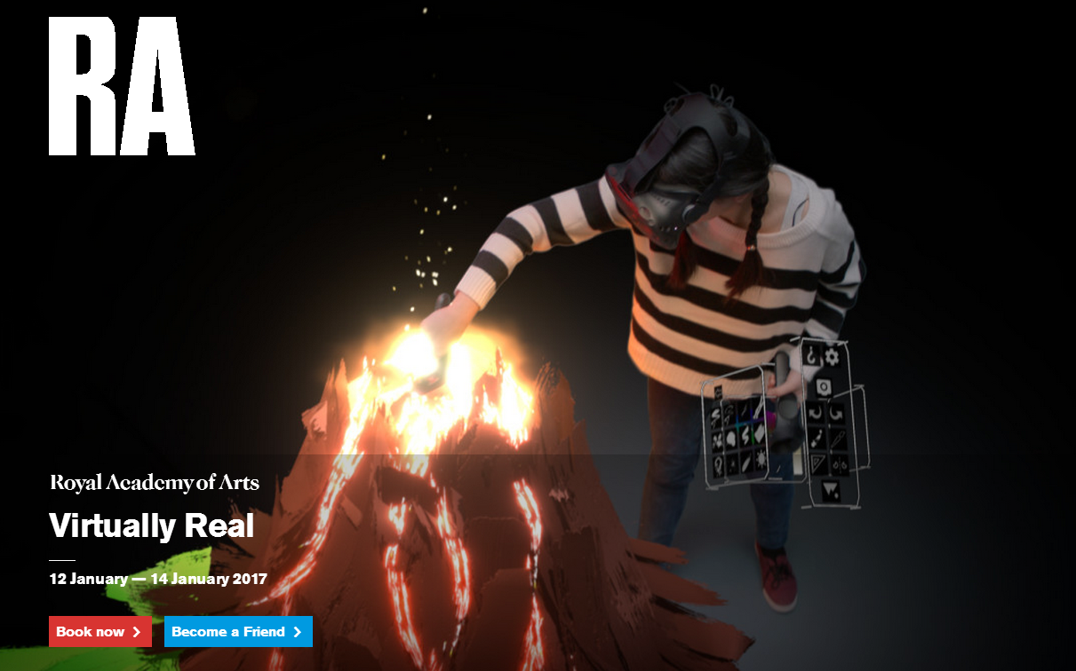

<https://www.royalacademy.org.uk/exhibition/project-virtually-real>